Xiaojun Ge

The Battle of Neighborhoods

[Document subtitle]

Table of Contents

Introduction of business project, target audience 1

Introduction & Background 1

Target Audience 2

Source of data 2

Exploratory data analysis 5

Step 1: Download and explore dataset 5

Step 2: Explore Neighbourhoods in Queens 8

Step 3: Analyse neighbourhood in Queens 10

Step 4: Analyse Italian restaurants in Queens 12

Step 5: Conclusion 16

# Introduction of business project, target audience

## Introduction & Background

New York City, which is often called as New York, is the most popular city in the USA, and also it is the most densely populated city in USA. New York City has been described as the cultural, financial and the media capital of the word, which significantly influence the commerce, entertainment, technology, financial of the world.

With the population of almost 20 million people in its metropolitan statistical area, New York City can be described as one of the most competitive city of the world. Due to expensive rental fee and competitivity, thus the analysis and choice of location is essential for new business need to be carefully.

In this assignment, we will investigate in New York City, how do we choose best location to open a restaurant and get the most benefit by using the Foursquare by providing the location data and venue information. As investigated, Italian families immigrated into the USA in the late 19th and 20th century. So with a huge population of immigration of Italians, they must need to find the restaurant which suitable for them.

In this report, I will focus on exploring on the locations & which neighbourhood and boroughs of New York City have the most Italian restaurants that can suitable for the Italian immigrants' flavour. Moreover, I will investigate if I want to open an Italian restaurant, where should I open?

## Target Audience

This project/report aims to provide information and analysis to the New York City restaurant overview and analysis to business stakeholders who may want to invest and open a restaurant in New York.

By looking through this report, business stakeholders will have a virtual overview on which location has the most restaurant and where is the best location for stakeholders to choose to open the restaurant.

# Source of data

1. In order to obtain the basic background and information for New York City, information get from the website: <https://en.wikipedia.org/wiki/New_York_City>, where list out the basic history, population, location etc for stakeholders to get a overview of New York City

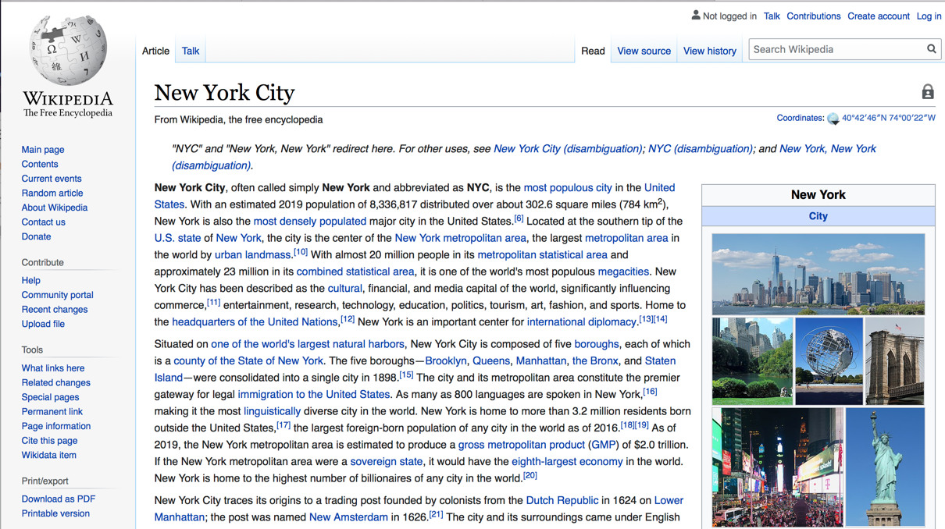

Figure 1 Basic background and information for NYC

1. Since New York City has 5 boroughs, so in order to segment the neighbourhoods and explore, we need to find the dataset which contains 5 boroughs and neighbourhoods as well within each borough. Latitude and Longitude of each neighbourhood are also needed in the dataset. The available link for this dataset is: <https://geo.nyu.edu/catalog/nyu_2451_34572>

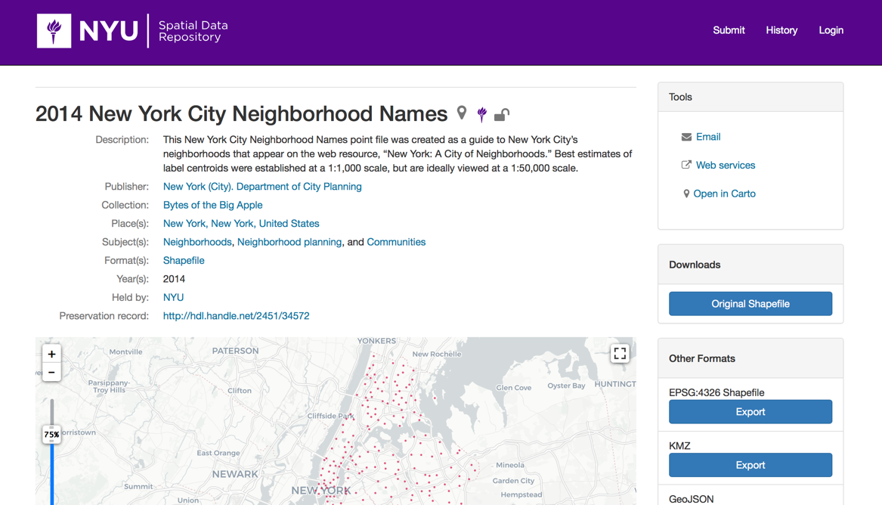

Figure 2 Boroughs and neighbourhoods dataset

1. The link which can directly download the dataset as mentioned in point 2: <https://cocl.us/new_york_dataset>

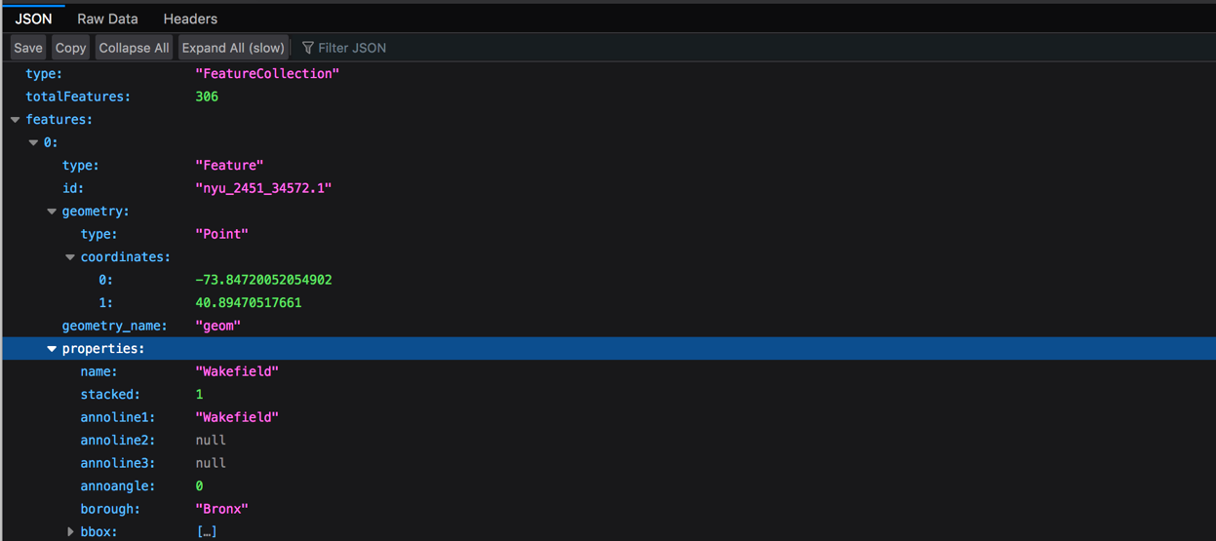

Figure 3 Boroughs and neighbourhood dataset

1. Foursquare API, which has the link of <https://developer.foursquare.com/> will be used as well to investigate the dataset of New York City and neighbourhoods and then will use method of clustering to cluster those neighbourhoods for Italian restaurants in order to get the detailed information.



Figure 4 Foursquare API

# Exploratory data analysis

So in order to analyse and find the best location and restaurant in New York City for Italian restaurant opening, we need to analyse detailed information in New York City and its neighbourhoods.

Firstly let us download and import all dependencies we needed.

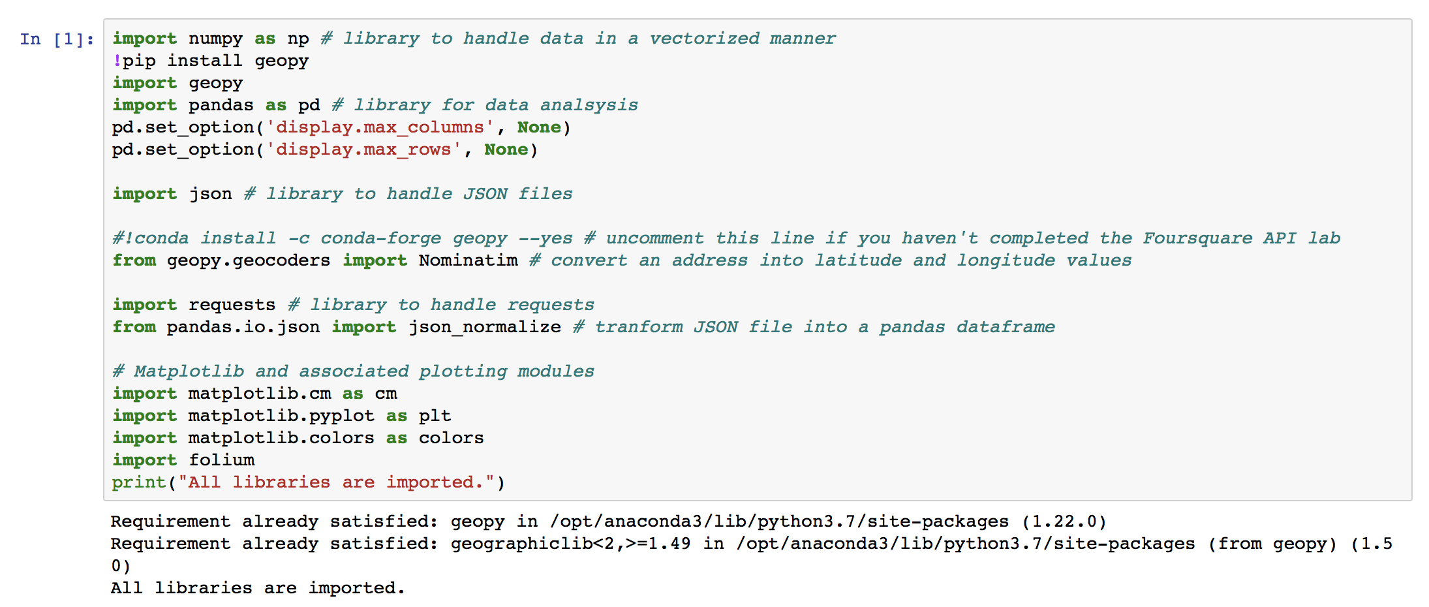

Figure 5 Download and import all libraries and dependencies

## Step 1: Download and explore dataset

Firstly, I perform the action of download the New York City dataset from the website <https://cocl.us/new_york_dataset> and then I open it in json format.

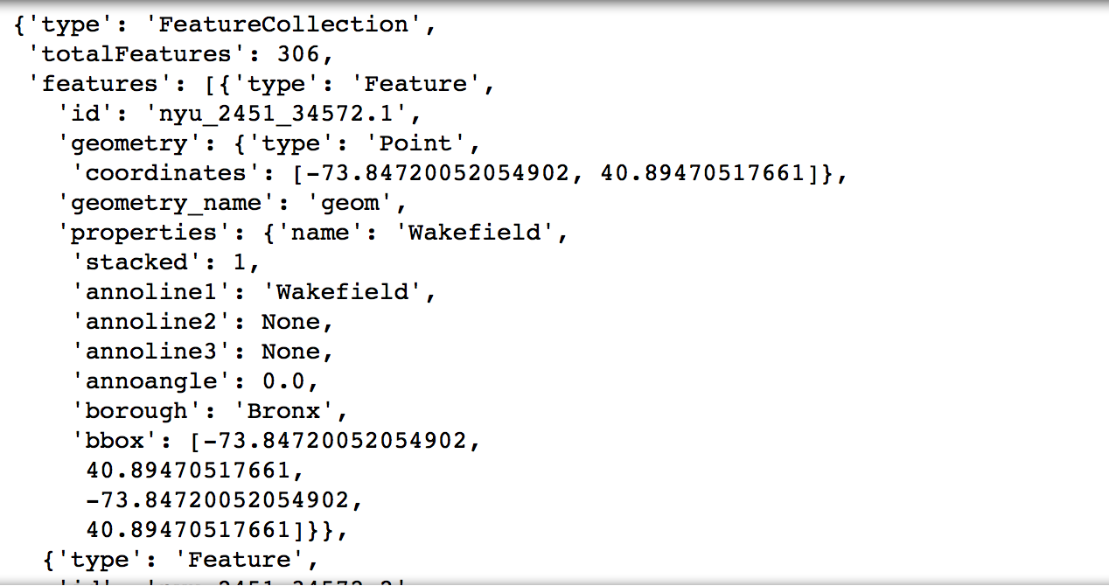

Figure 6 New York dataset in json format

Now we define a function to get the New York city data such as Boroughs, Neighbourhoods along with their latitude and longitude and show 5 example rows of it.

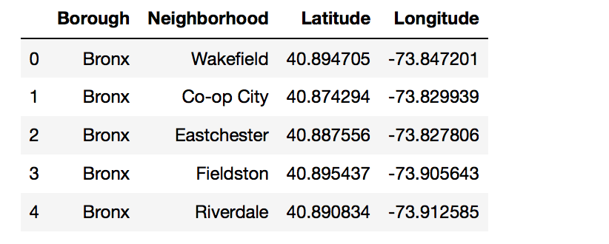

Figure 7 Neighbourhood information for New York City

We use the shape function to see how many neighbourhoods of New York we have and we found that there are 306 neighbourhoods there in New York, which are in 5 borough.

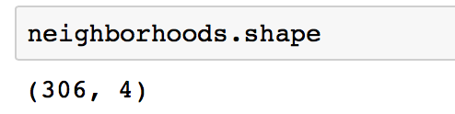

Figure 8 Number of neighbourhoods in New York

Now we print out number of borough and neighbourhoods in a more clear format.

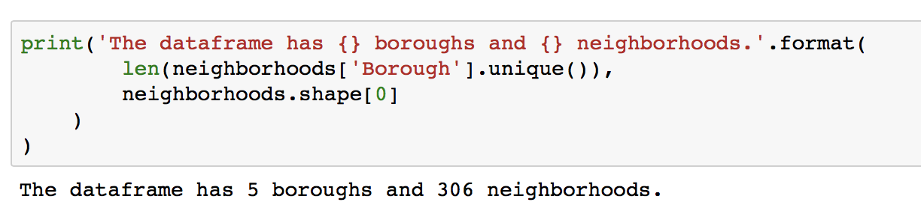

Figure 9 Number of boroughs and neighbourhoods in New York

Then I want to draw a bar chart to visualize these 5 boroughs and 306 neighborhoods.

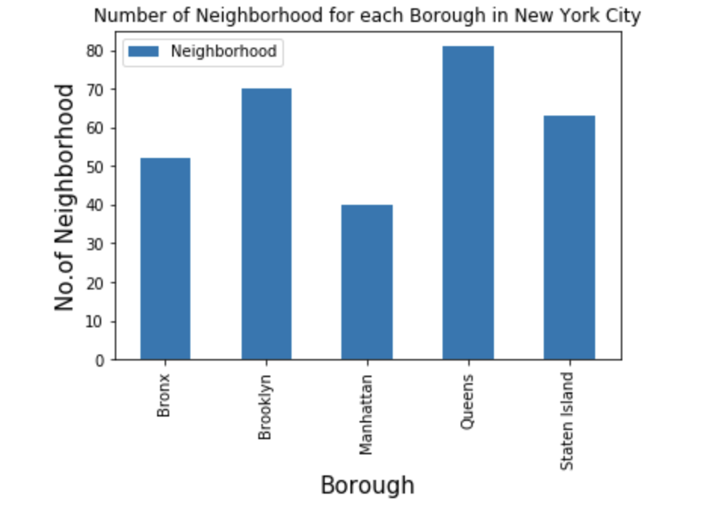

Figure 10 Bar chart of New York borough and neighbourhoods

Based on the bar chart, we can clearly see that Queens is the borough which has the most neighborhoods. So, in the next section, I will focus on Queens to analyze into more details.

For now, I would like to show the visualization of map of New York and Queens to give a more visual on neighborhoods allocation.

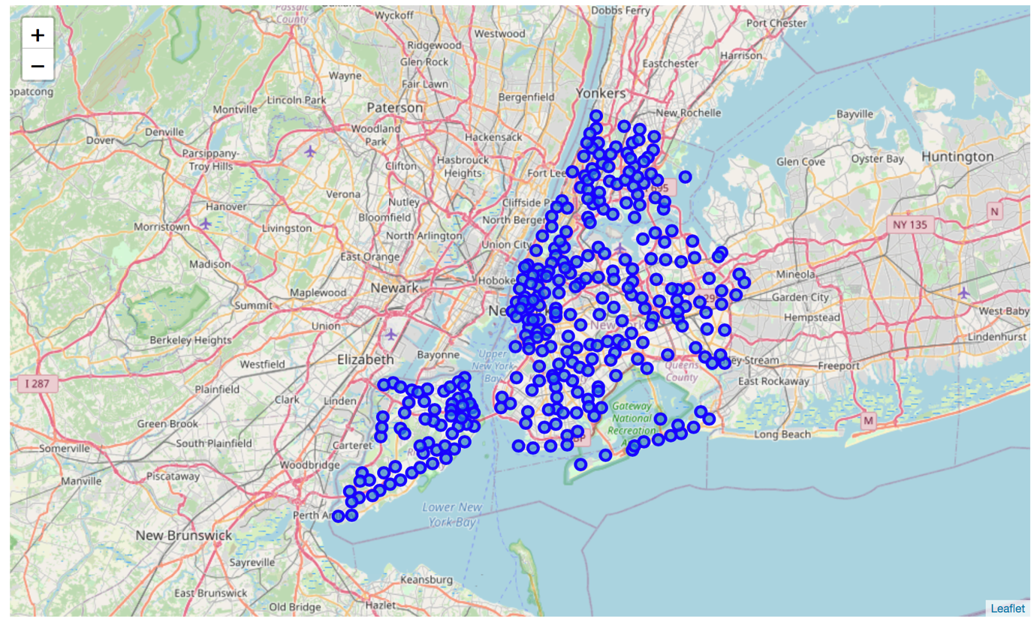

Figure 11 Map of New York City

Now we only filter out dataset contains Queens and we create a map to visualize on Queens neighbourhood again.

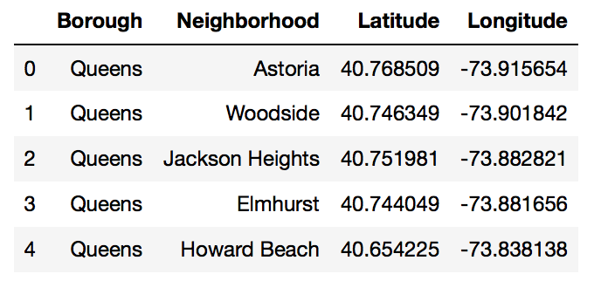

Figure 12 Dataset of Queens

After we get the geo-location of Queens, I create a map for Queens and its neighbourhoods.

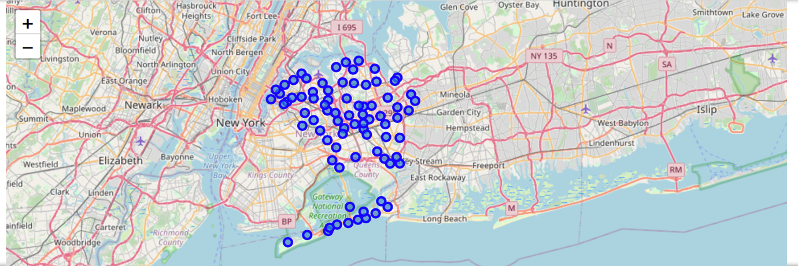

Figure 13 Map of Queens and its neighbourhoods

## Step 2: Explore Neighbourhoods in Queens

After we passing through Foursquare API credentials, we want to use it to explore details for Queens, so firstly I print 5 neighbourhoods of Queens as example.

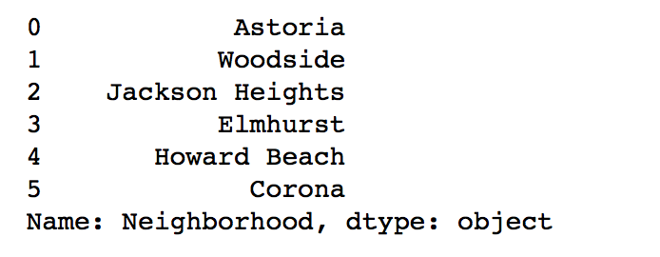

Figure 14 5 examples of neighbourhoods in Queens

Now we find geo-location of them as well as reference.

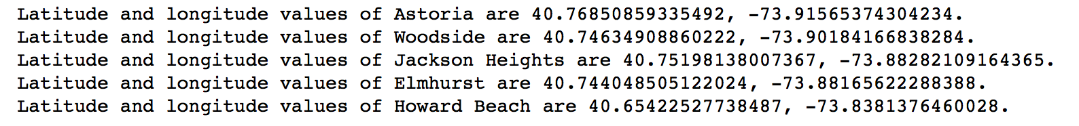

Figure 15 Geo-location of neighbourhoods in Queens

Then after we pass through our credentials, fix our limit, radius etc, we get the response from foursquare API in json format.

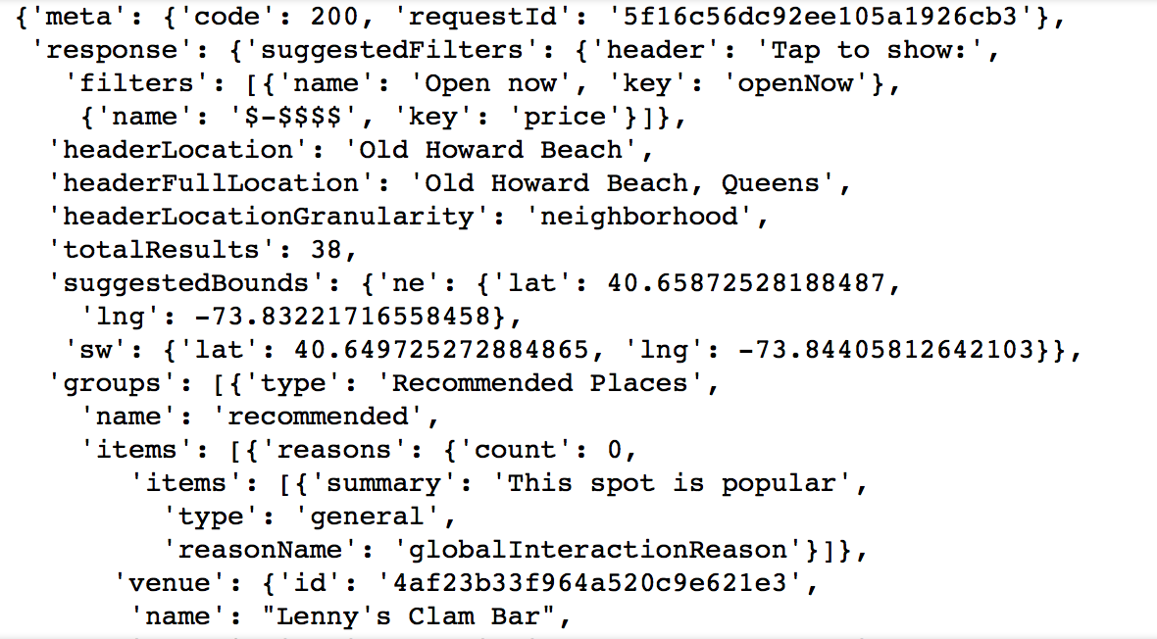

Figure 16 Foursquare API response

Within radius(I set as 500m) and limit(100) in Queens, I get 5 venues examples to show out with their name, category and their geo-location.

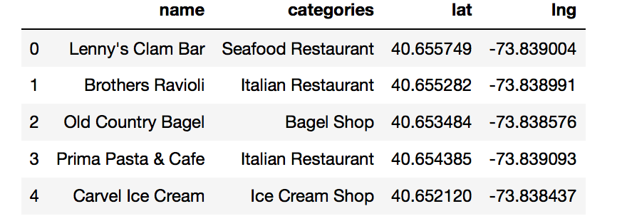

Figure 17 Venue examples in Queens

After expand the radius to 1000m, there are more and more neighbourhoods and venues appear, using the shape function, there are 5241 venues there and I take 5 examples here.

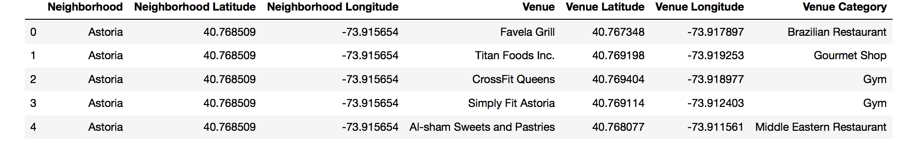

Figure 18 Examples of venues after radius expand to 1000m

The format just now seems complex to visualize, now I group each venue into neighbourhoods in Queens and show them again.

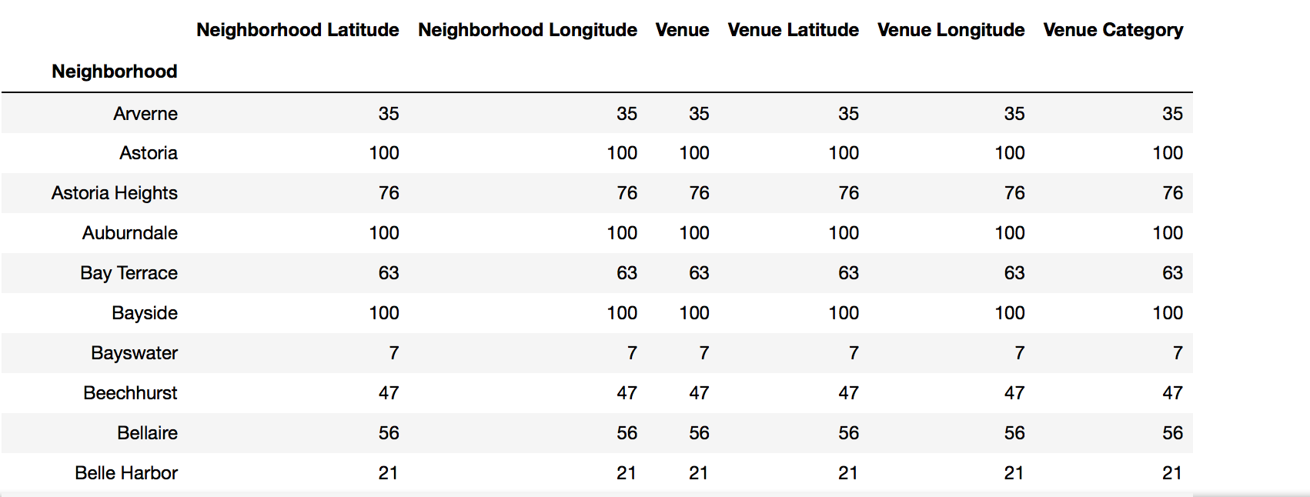

Figure 19 Group into Queens neighbourhoods

## Step 3: Analyse neighbourhood in Queens

Now as we already identify all neighbourhoods in Queens, we can analyse each neighbourhood in details.

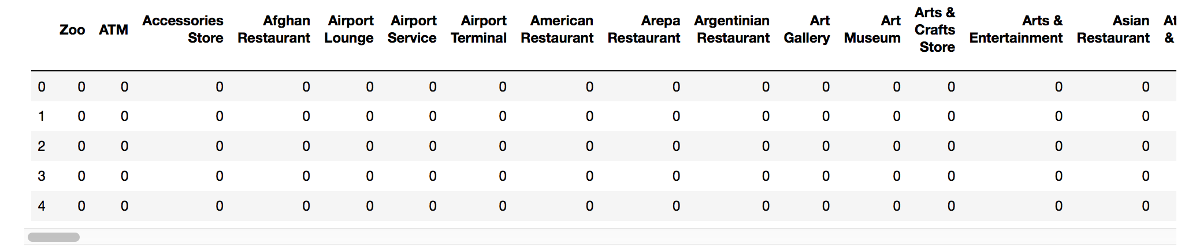

Figure 20 Convert categorical into numerical

Then based on the numerical number we are easily to calculate number of occurrence frequency for each category.

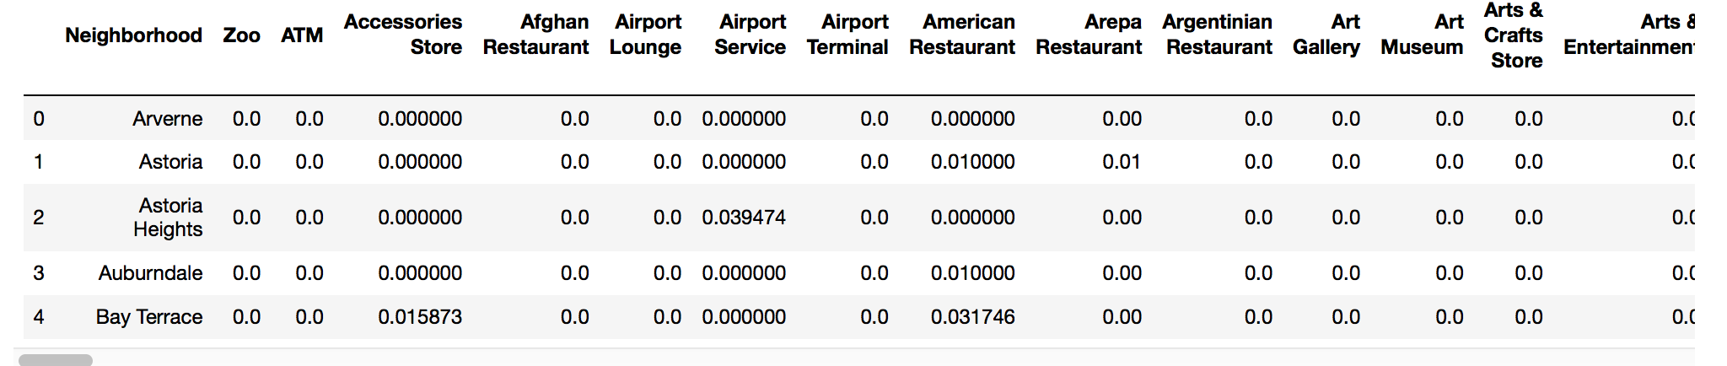

Figure 21 Number of occurrence frequency per category

Now we want to target analyse on Italian restaurants in Queens and see how many are there in each neighbourhood in Queens and here is the result.

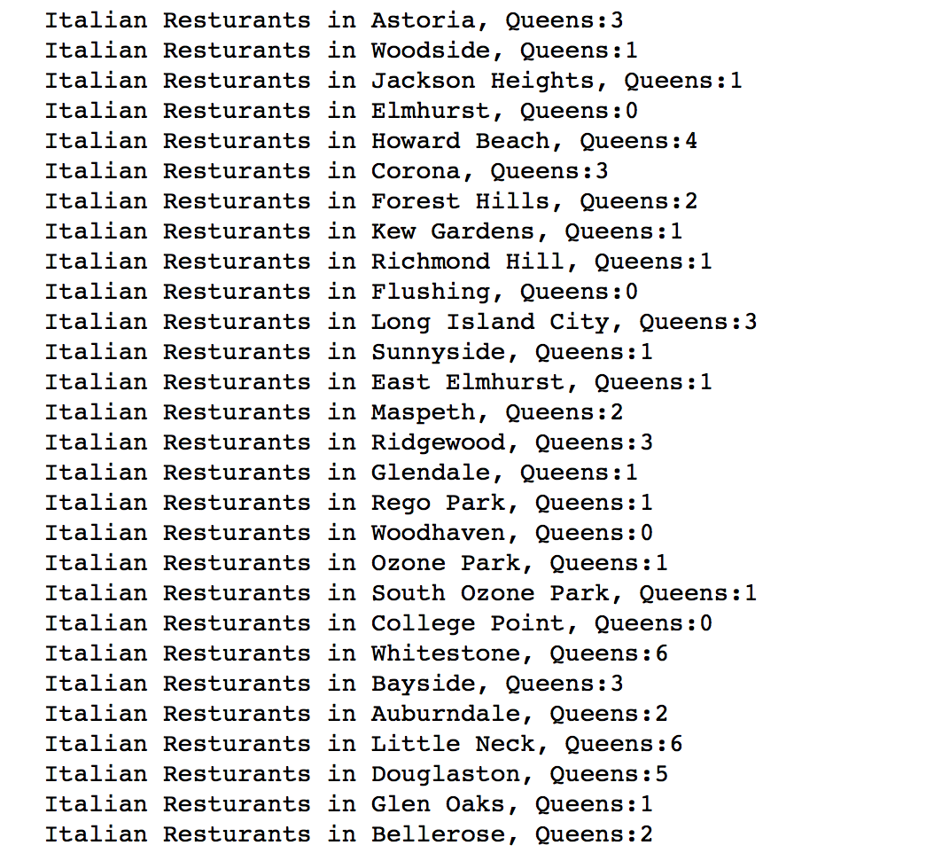

Figure 22 Italian restaurants in Queens

We show it in a table format with 5 examples.

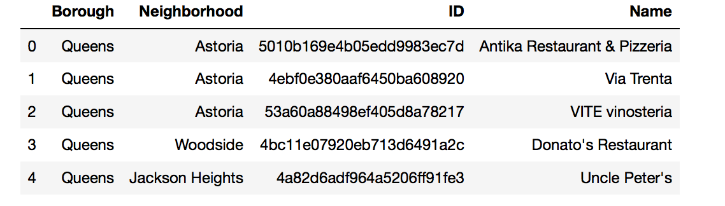

Figure 23 Italian restaurant in Queens

Write a function to show it in the bar chart format and from the bar chart we can easily identify that Hunters Point has the most Italian restaurant in Queens.

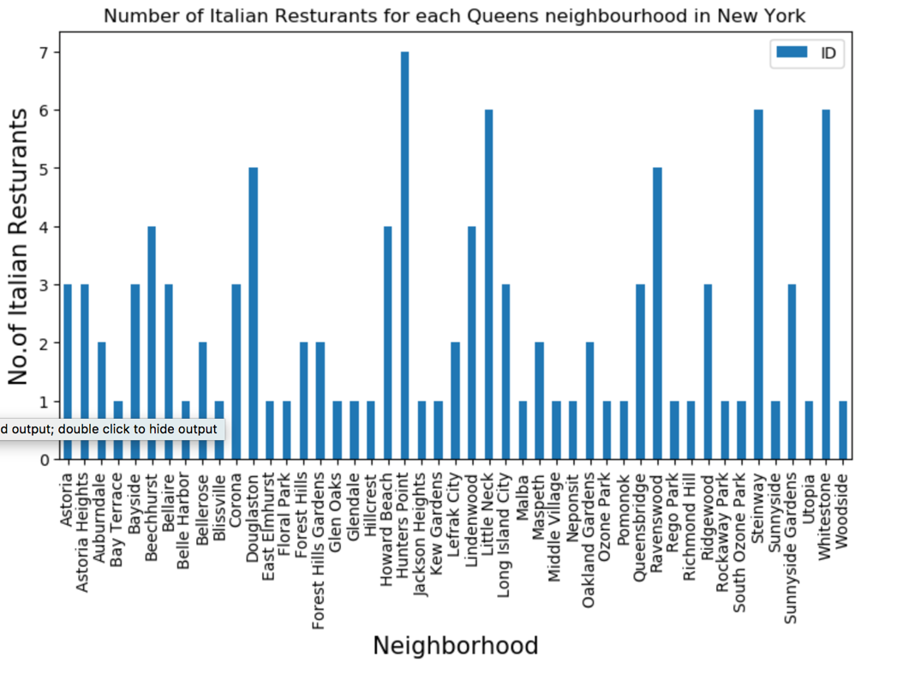

Figure 24 Allocation of Italian restaurants in Queens

Now let us have an overall view of Italian restaurants in Hunters Point.

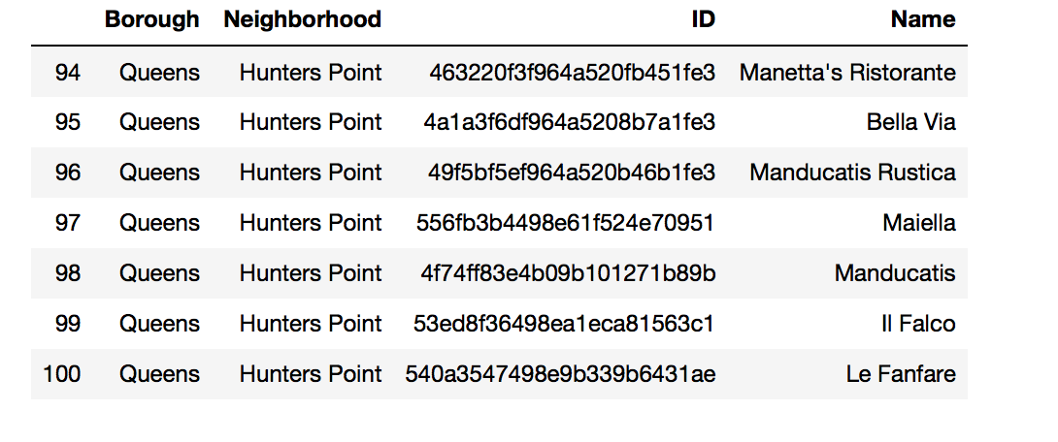

Figure 25 Italian restaurants in Hunters Point

## Step 4: Analyse Italian restaurants in Queens

Although Hunters Point has the most Italian restaurants, we still need to analyse overall status in Queens which will have a more accurate evaluation.

I write a function which able to find restaurant’s tips, ratings and likes which I put them into a table format and shows here.

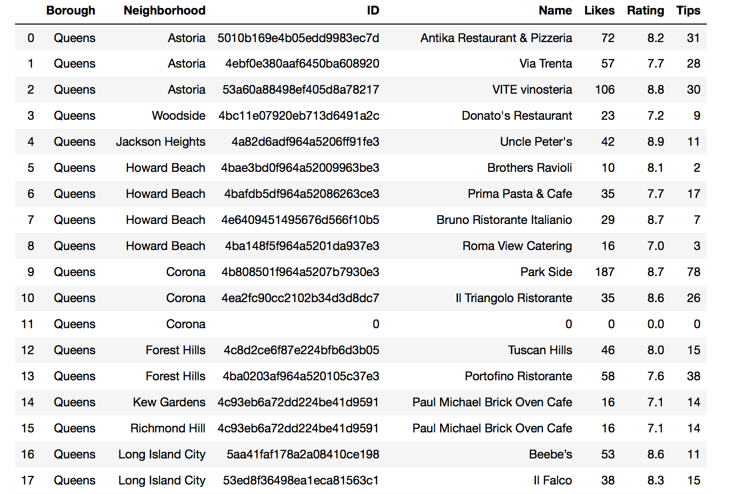

Figure 26 Italian restaurants venue details

Then I display datatypes for each column to show dtype for each. Found that Likes and Tips should convert to float64 for easily process future.

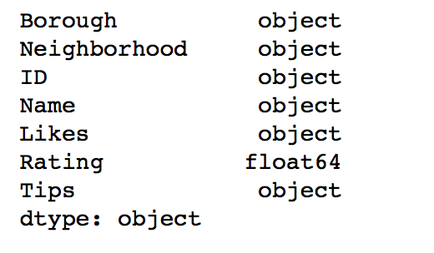

Figure 27 dtypes for each column

After converting, it will be easily for us to find the Italian restaurant which has the most tips, highest rating and most likes.

Firstly I would like to find out which Italian restaurant has the most likes in Queens.

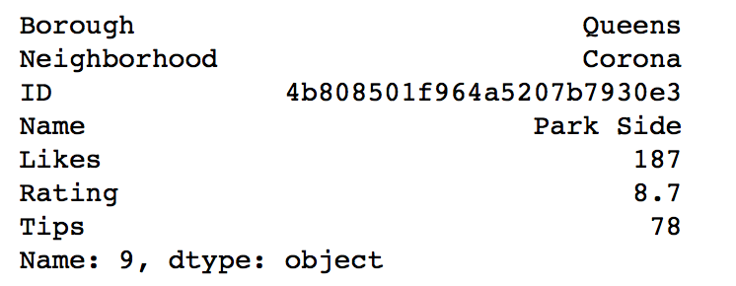

Figure 28 Italian restaurant which has most likes

Secondly I would like to find out which Italian restaurant has the highest rating in Queens.

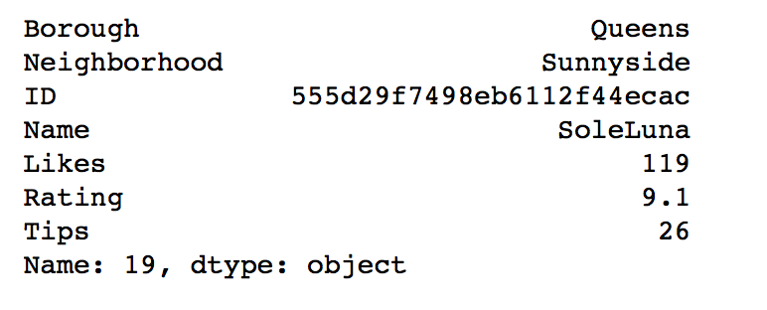

Figure 29 Italian restaurant which has highest rating

Thirdly I would like to find out which Italian restaurant has the most tips in Queens.

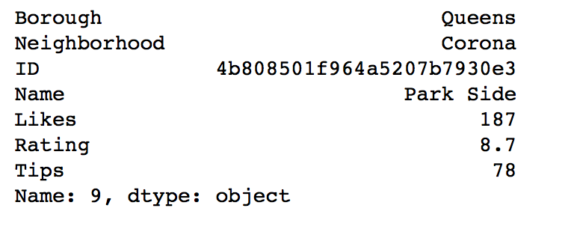

Figure 30 Italian restaurant which has most tips

After that, I want to show the average rating of each neighbourhood in Queens which has Italian restaurants.

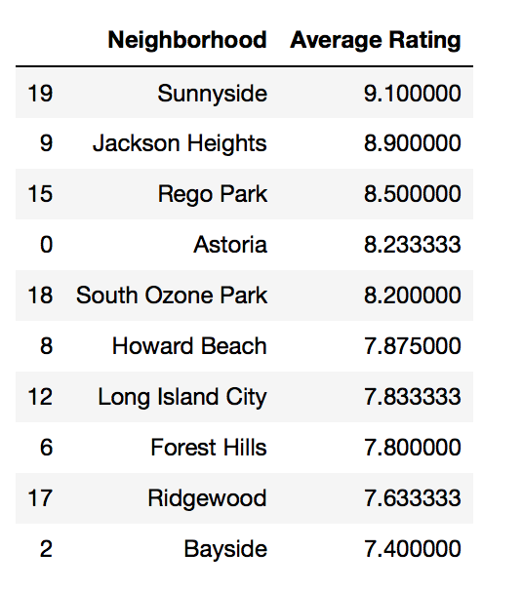

Figure 31 Average rating of neighbourhoods in Queens

I put them into a bar chart format which will be shown more clearly. Based on bar chart we can see that Sunnyside is the one which shows the highest, followed by Jackson Heights etc.

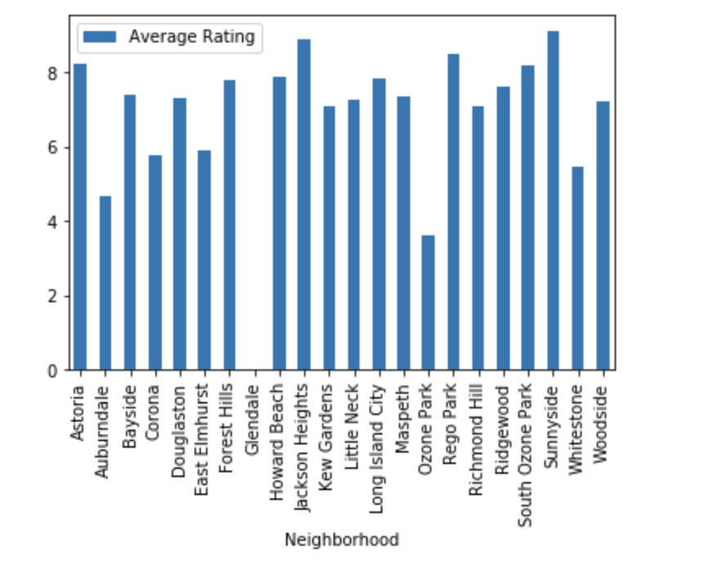

Figure 32 Average rating of neighbourhoods in Queens

Lastly, we filter out the neighbourhoods which has the Italian restaurant which has the rating score >=8.5.

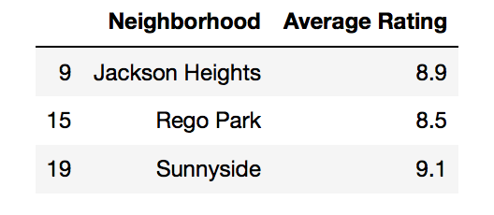

Figure 33 Average rating >=8.5

## Step 5: Conclusion

Some findings and analysis after done the assignment:

1. Queens has the most neighbourhoods among all 5 borough in New York City.

2. Hunters Point has the most Italian restaurant in Queens.

3. Park Side - Corona is the one which has the most LIKES by customers in Queens.

4. SoleLuna - Sunnyside has the highest RATING by customers in Queens.

5. Park Side - Corona has the most TIPS by customers in Queens.

6. Overall in Queens, Sunnyside has the highest average rating regards of Italian restaurants.